**1.Title: Online Event Management System**



**2.Project Statement:**

The project aims to develop a user-friendly web application that facilitates the

Selection of Events according to the requirement in the co-corporation. Event management is the application of [project management](https://en.wikipedia.org/wiki/Project_management) to the creation and development of large scale events such as [festivals](https://en.wikipedia.org/wiki/Festival), conferences, ceremonies, formal parties, concerts, or [conventions](https://en.wikipedia.org/wiki/Convention_(meeting)). It involves studying the brand, identifying the [target audience](https://en.wikipedia.org/wiki/Target_audience), devising the event concept, and coordinating the technical aspects before actually launching the event

**Outcomes:**

Allow the creation and development of large scale events such as [festivals](https://en.wikipedia.org/wiki/Festival), conferences, ceremonies, formal parties, concerts, or [conventions](https://en.wikipedia.org/wiki/Convention_(meeting)). It involves studying the brand, identifying the [target audience](https://en.wikipedia.org/wiki/Target_audience), devising the event concept, and coordinating the technical aspects before actually launching the event

Enhance employees satisfaction by offering a seamless and user-friendly interface.

1. **Modules to be implemented**
2. User Authentication and Registration
3. Appointment Scheduling Interface
4. Hall Availability Management
5. Booking Information Management
6. Appointment Management
7. Notification System
8. Admin Dashboard
9. **Week-wise module implementation and high-level requirements with output screenshots**

**Milestone 1: Weeks 1-3**

**Module 1: User Authentication and Registration**

* Implement user registration functionality.
* Develop user login mechanism.
* Integrate email verification and password reset features.
* Output screenshoot:

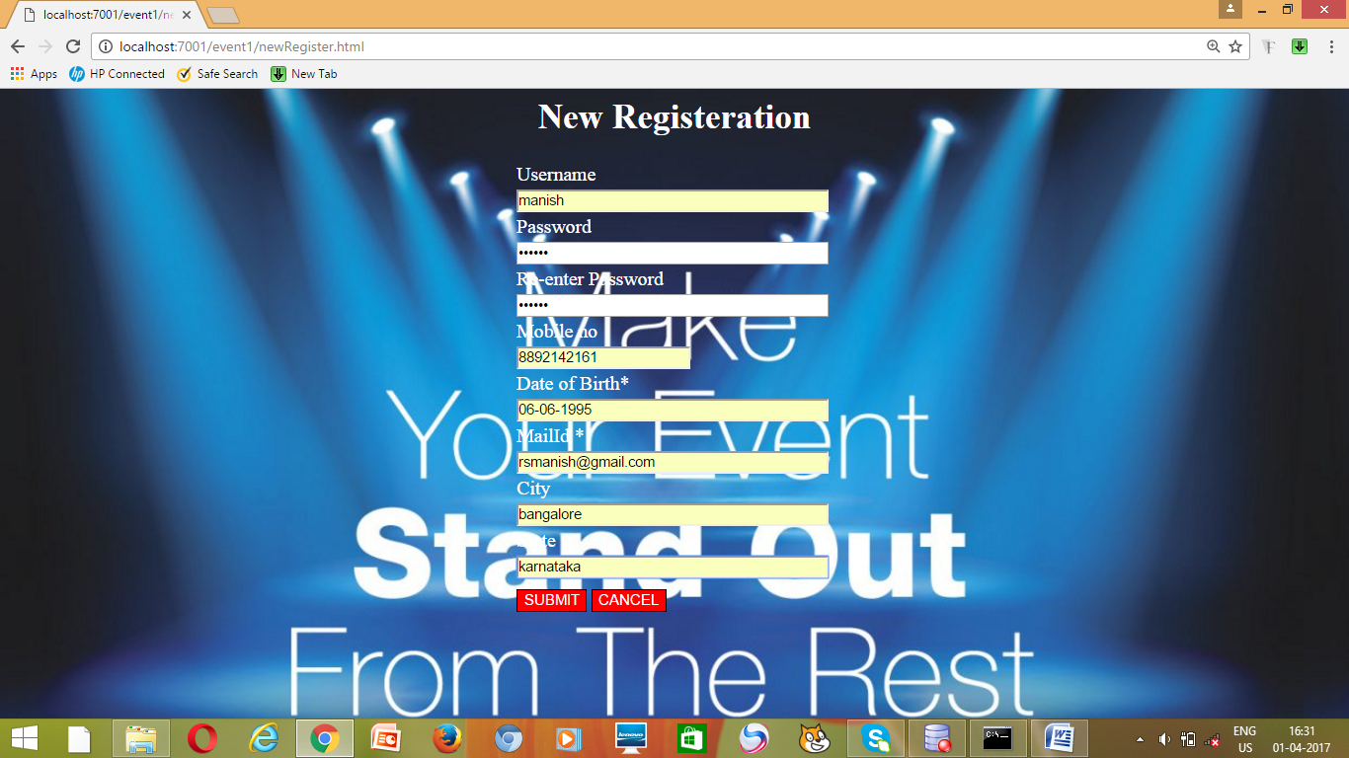

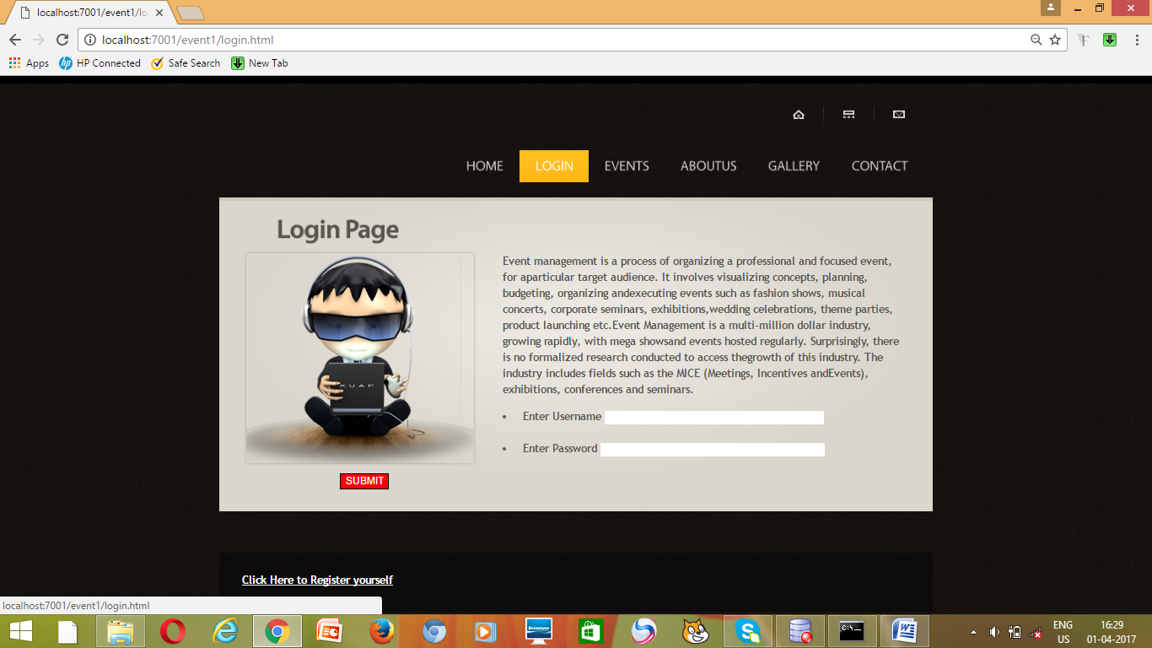

**Module 2: Hall Availability Management**

* Design database schema for storing Hall availability information.
* Develop an interface for Hall to set their availability.
* Implement backend functionality to manage and update Hall availability.
* Output screenshot

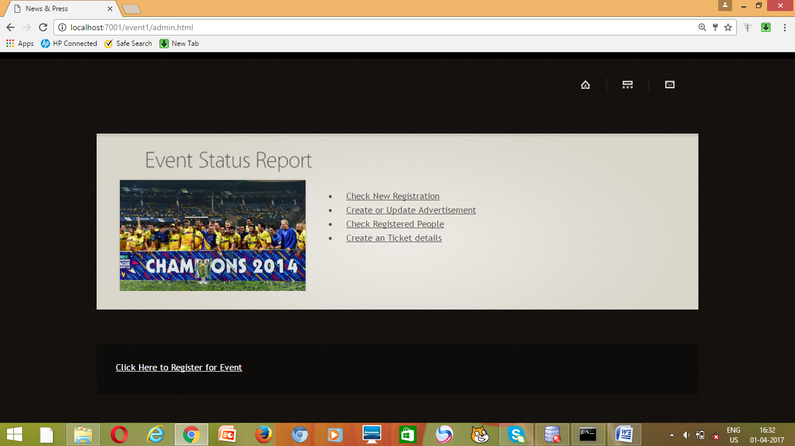

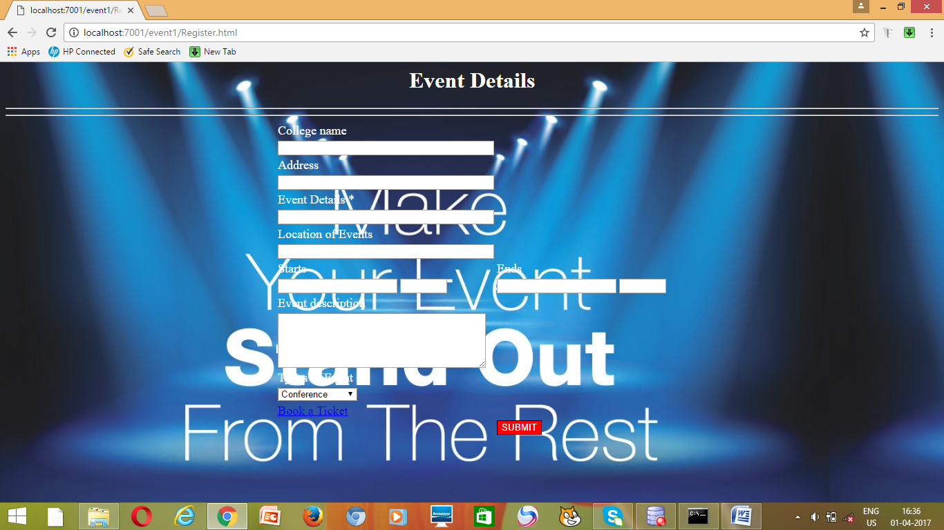

**Milestone 2: Weeks 4-5**

**Module 3: Appointment Scheduling Interface**

* Design and develop the interface for appointment scheduling.
* Implement functionality for users to select hall, preferred time slots, and reasons for the Booking of Hall.
* Integrate the scheduling interface with the backend for storing appointment details.
* Output screenshot

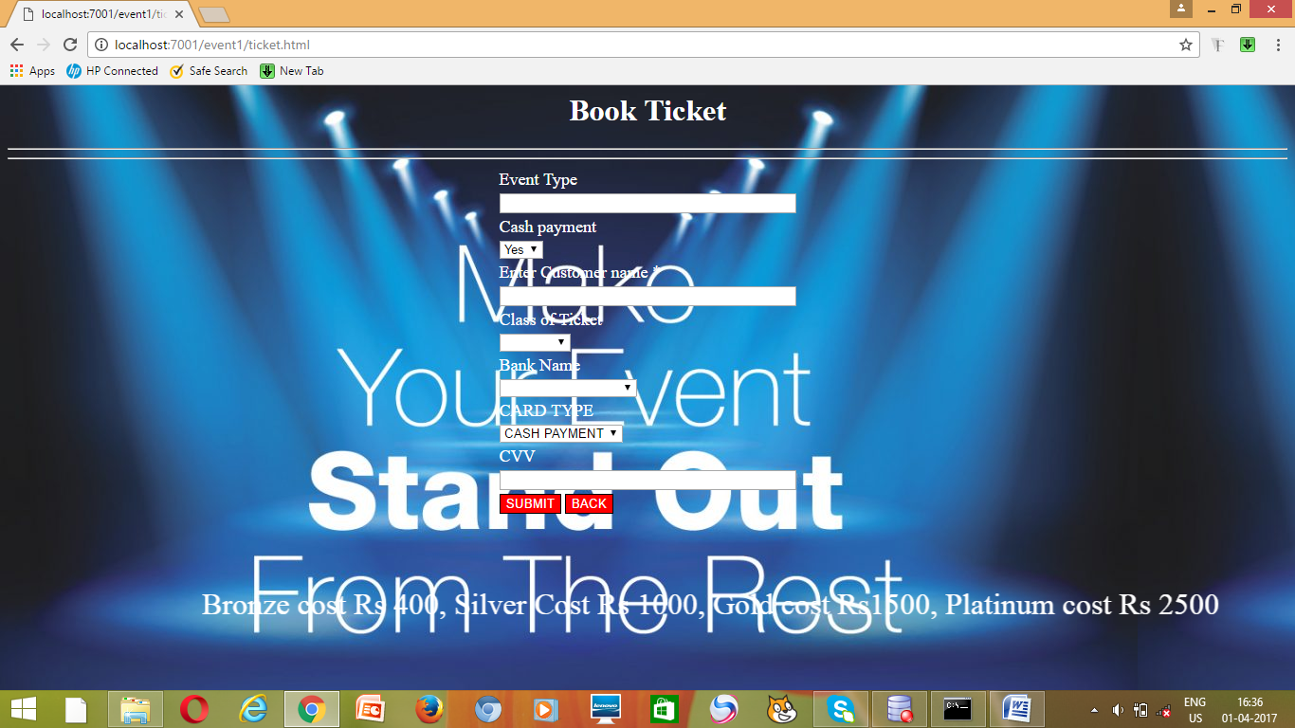

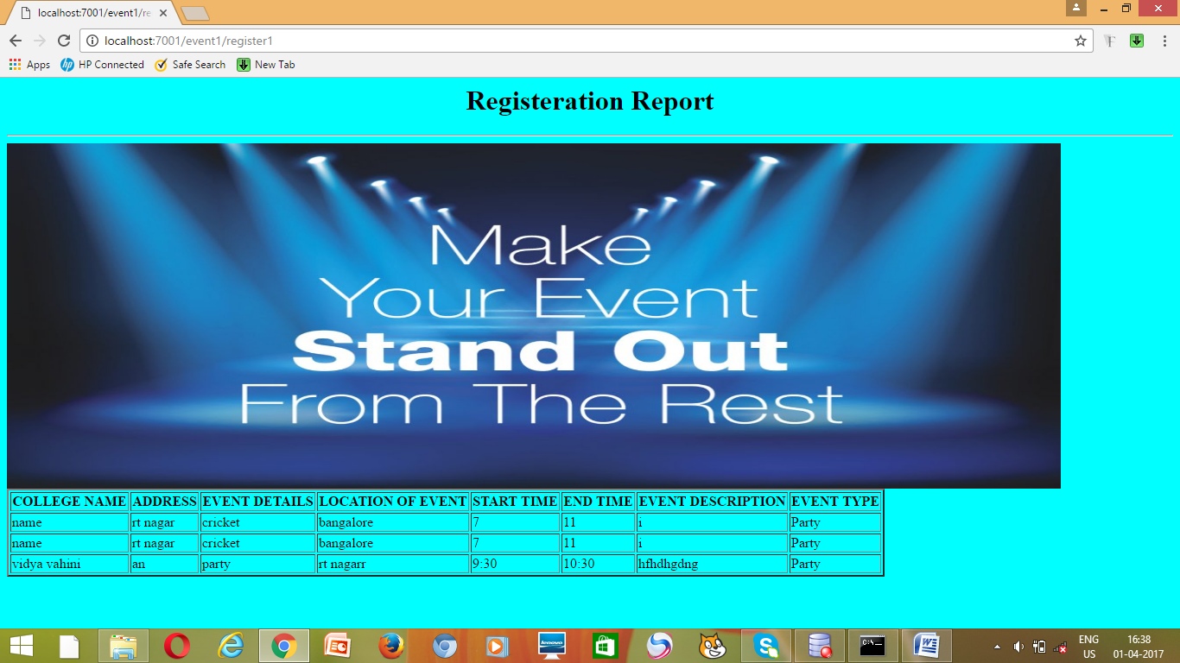

**Milestone 3: Weeks 6-7**

**Module 4: Appointment Management**

* Design database schema for storing appointment details.
* Implement backend functionality for scheduling appointments and preventing conflicts.
* Develop an interface for Organizer and Customer to view and manage appointments.
* Output Screenshot:

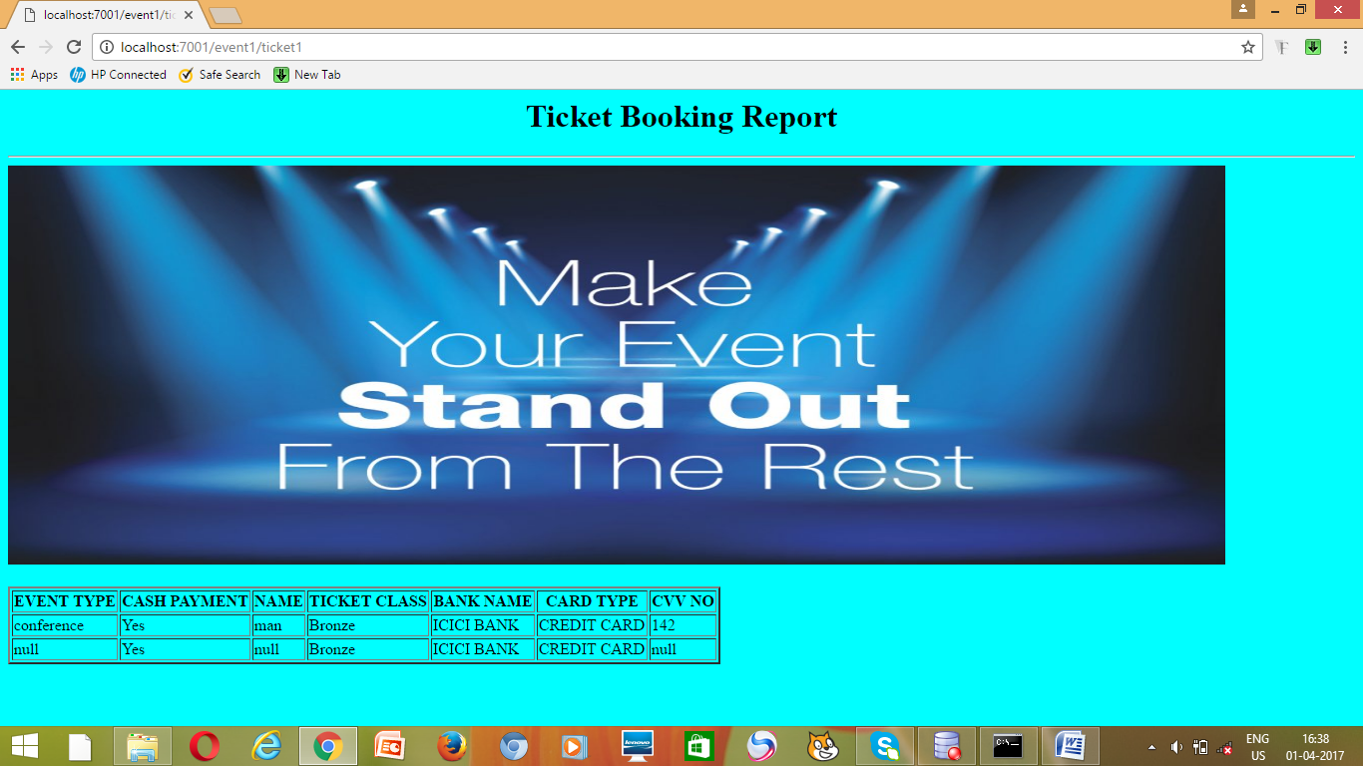

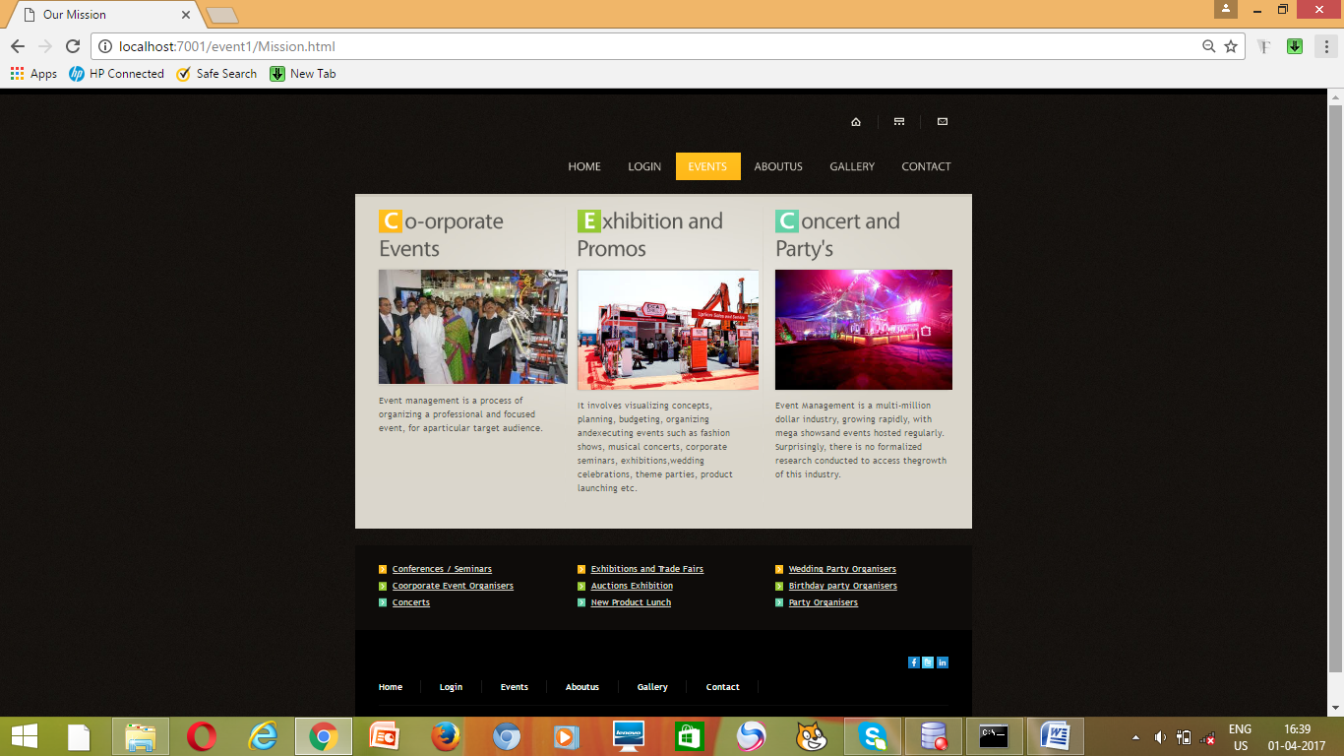

**Milestone 4: Weeks 8-10**

**Module 5: Customer Information Management**

* Design database schema for storing customer information securely.
* Develop functionality for customer to provide and update their information.
* Implement backend logic for accessing and managing patient information securely.
* Output Screenshot:

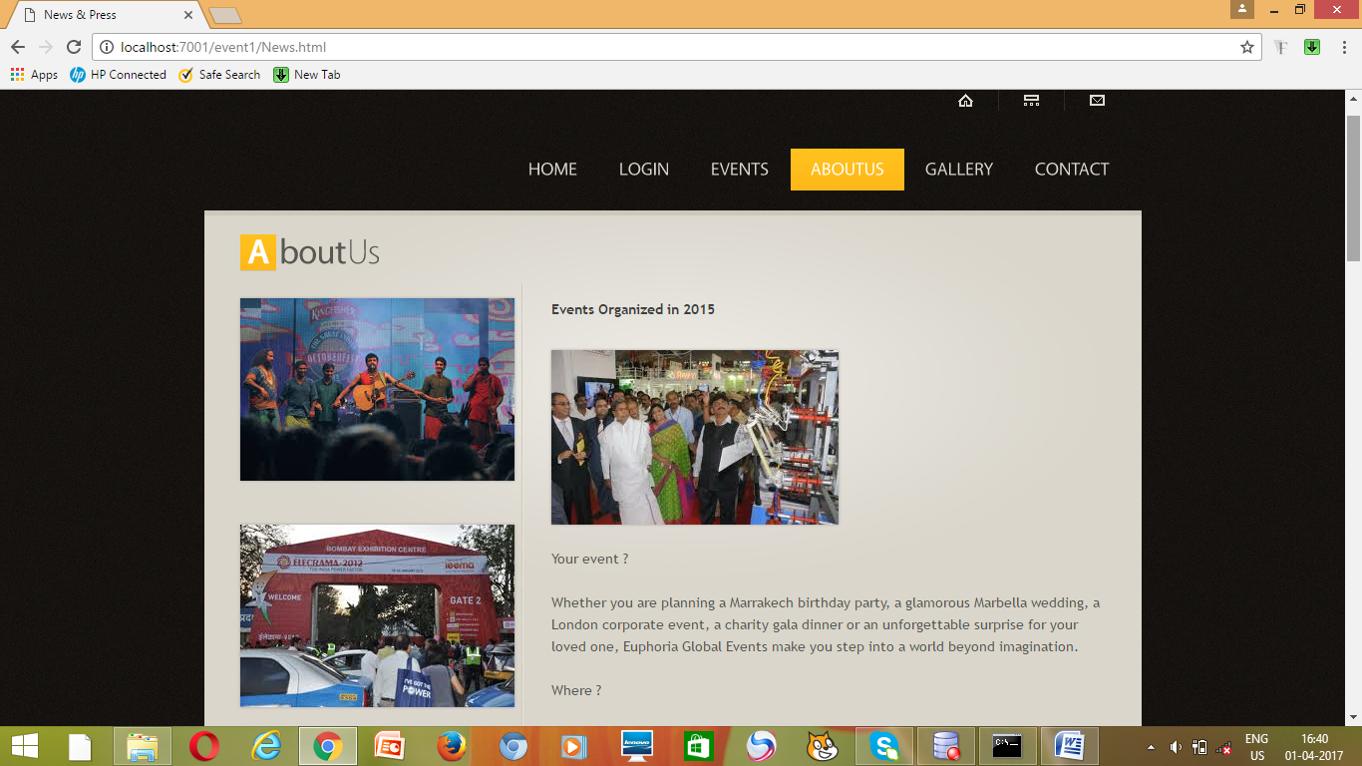

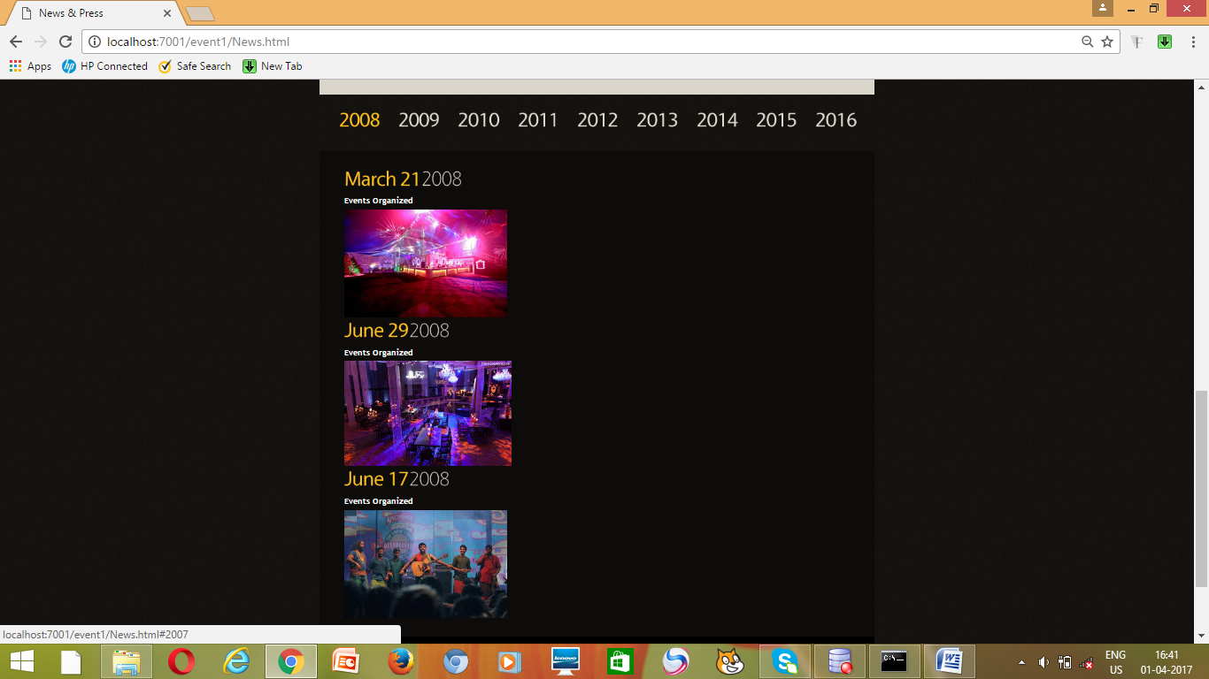

**Module 6: Notification System**

* Integrate email and/or SMS notification services.
* Develop triggers and notifications for appointment reminders, new bookings, and cancellations.
* Implement a system for handling and tracking notifications.
* Output screenshot:

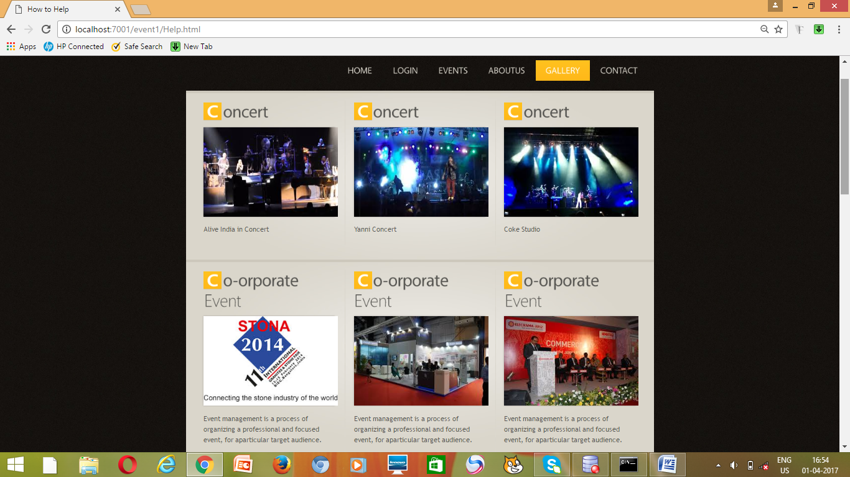

**Module 7: Admin Dashboard**

* Design the layout and functionality of the admin dashboard.
* Implement user management features for admins to add, edit, and delete users.
* Develop modules for managing doctors, appointments, and customer information.
* Output Screenshot:

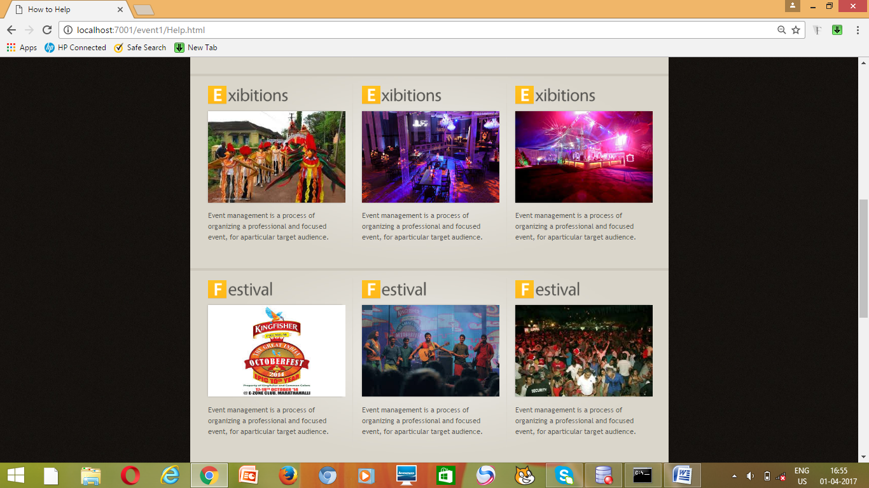

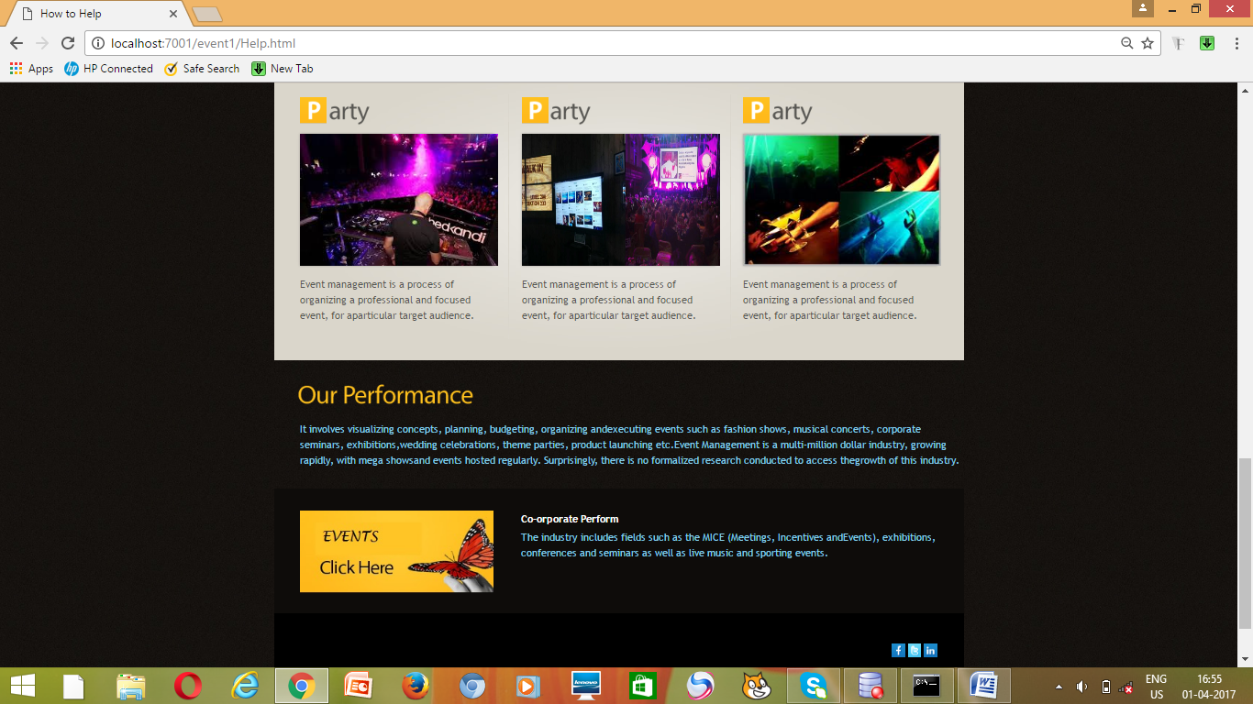

**Evaluation Criteria:**

**Milestone 1 Evaluation (Week 3):**

* Completion of user authentication and registration.
* Successful implementation of doctor availability management functionalities.

**Milestone 2 Evaluation (Week 5):**

* Appointment scheduling interface is fully developed and integrated with the backend.

**Milestone 3 Evaluation (Week 7):**

* Appointment management system is operational, allowing for scheduling and viewing appointments.

**Milestone 4 Evaluation (Week 10):**

* Patient information management, notification system, and admin dashboard are fully implemented and functional.

1. Design diagrams

Class Diagram: Entity classes

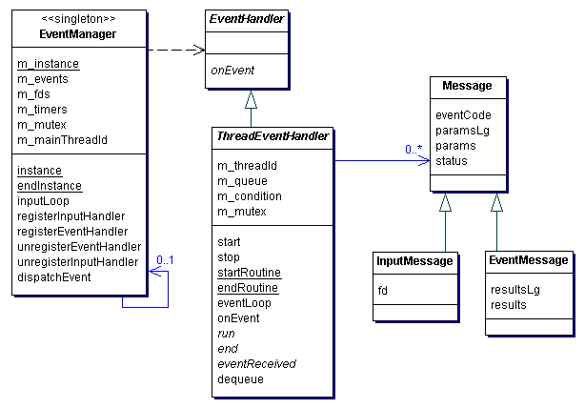

**Output Screenshots:**

1. Dashboard

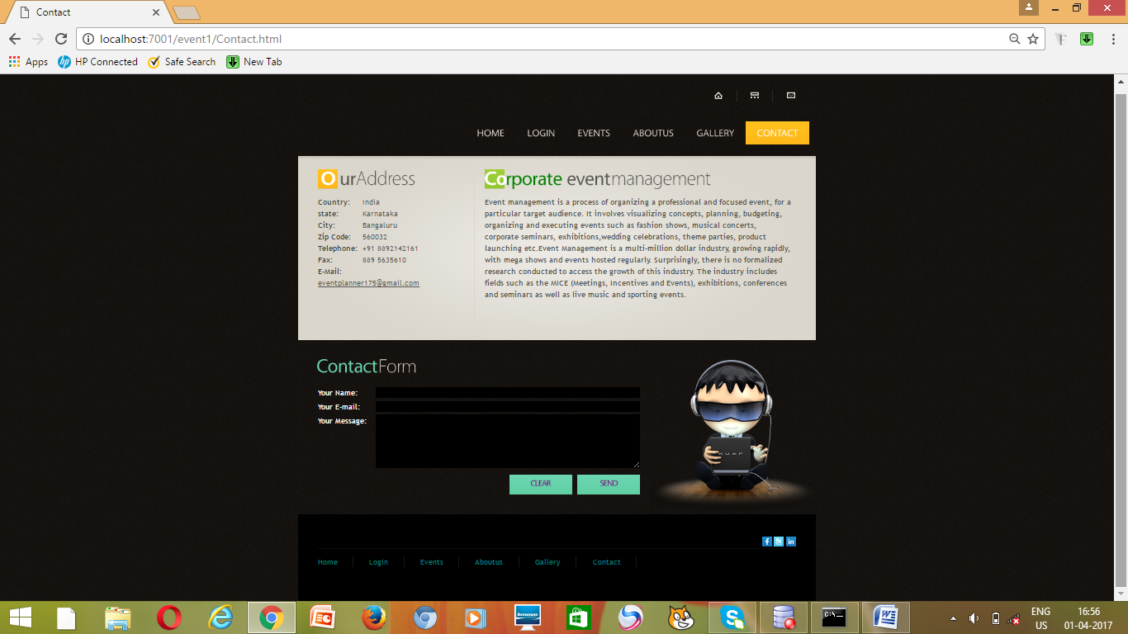

2. Admin Dashboard

